2805ICT System and Software Design
3815ICT Software Engineering
7805ICT Principles of Software Engineering
This is an assessed workshop
WORKSHOP 7 UML & second stage assessment

Student name: Nguyen Quang Huy Student ID: s5257464 Enrolled Course Code: 7805ICT

1 Software architecture (15pts)

- Give definitions of Architectural Drift and Architectural Erosion, use examples to explain their differences. (5pts)
  - Architectural drift is introduction of principal design decisions into a system’s descriptive architecture that
    - Are not included in, encompassed by, or implied by the prescriptive architecture
    - But which do not violate any of the prescriptive architecture’s design decisions
Example: the customer widen the scope of the project, which might create architectural drift, which will be increasingly difficult to further develop, maintain or even understand the code because design decisions are not always apparent when only looking at the code
  - Architectural erosion is the introduction of architectural design decisions into a system’s descriptive architecture that violate its prescriptive architecture.
Example: non-optimal coding practices make implementing new features gradually more difficult. Which make the only solution is to re-write the entire code from scratch

- Use examples to explain the difference between Reference Model and Architectural Pattern regarding Software Architecture (5pts)

- Architectural Pattern:
A description of element and relation types together with a set of constraints on how they may be used.
  - A set of constraints on an architecture
  - Define a set or family of architectures
  - An architectural pattern is not an architecture
  - Exhibit known quality attributes
  - Often the architect’s first major design choice
  - "Architectural style" has also been widely used
  - Example: "Client-Server"
- Reference Model:
A division of functionality together with data flow between the pieces.
  - Standard decomposition of a known problem into parts that cooperatively solve the problem.
  - characteristic of mature domains
  - Example: Compiler; database management system

- Use diagram and examples to explain the Architecture Business Cycle (ABC) (5pts)

Architecture Business Cycle (ABC):

“Software architecture is a result of technical, business, and social influences. Its existence in turn affects the technical, business, and social environments that subsequently influence future architectures. We call this cycle of influences, from the environment to the architecture and back to the environment, the Architecture Business Cycle (ABC).”
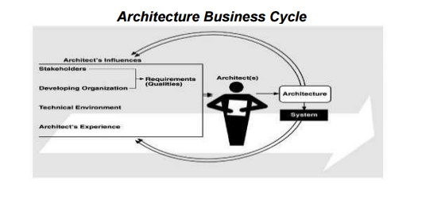

- Stakeholders: who sets the requirements for the architecture, example: end user
- Organizations: which organization actually develop the architecture
- Technical environment: example: standard industry practices
- Architects’ experience: a more experienced architect can design a better architecture system

2 Views (15pts)

- In software architecture documentation, what are the three common viewtypes? Briefly explain the purpose of each viewtype.(5pts)

3 common viewtypes:
Module (Design/Functional Structure): contains views of the elements you can see at compile-time
Component and Connector (Runtime): contains views of elements that you can see at runtime
Allocation (Deployment, Physical Structure, Team Structure): contains views of elements related to the deployment of the software onto hardware

- Client & Server and Peer to Peer are two common c&c styles. Explain the similarity and difference between the two styles. Use examples to show how the two styles are used in software systems (you need to draw one diagram for each style). (10pts)
  - Similarities:
    - Both peer-to-peer and client-server networks connect computers so that resources like files and applications can be shared
  - Differences:
    - Peer-to-peer networks involve two or more computers pooling individual resources such as disk drives, DVD players and printers. These shared resources are available to every computer in the network
    - In peer to peer network, each computer acts as both the client and the server, communicating directly with the other computers
    - A client-server network involves multiple clients, or workstations, connecting to at least one central server
    - In a client-server network, most data and applications are installed on the server. When clients need access to these resources, they access them from the server
    - In a client-server network, servers often have private user directories as well as multiple public directories
    - Client-server networks tend to have faster access speeds because of the large number of clients they are designed to support
    - In a client-server network, it is easier to upgrade software applications and files because they are held on one single computer
    - In a client-server network, security is enhanced on a client server network because the security is handled by the server.
  - Diagrams examples:
    - Peer-to-peer: BitTorrent, a network in which files are stored on clients system instead of a server.
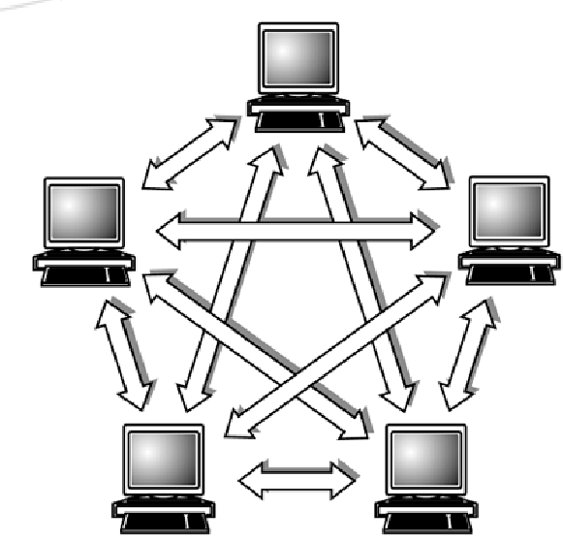

    - Client-server: in most websites, amazon for example, the user type in their browser an URL (and possibl, the server (which is amazon’s server) receive the URL and return to the client the information they queried
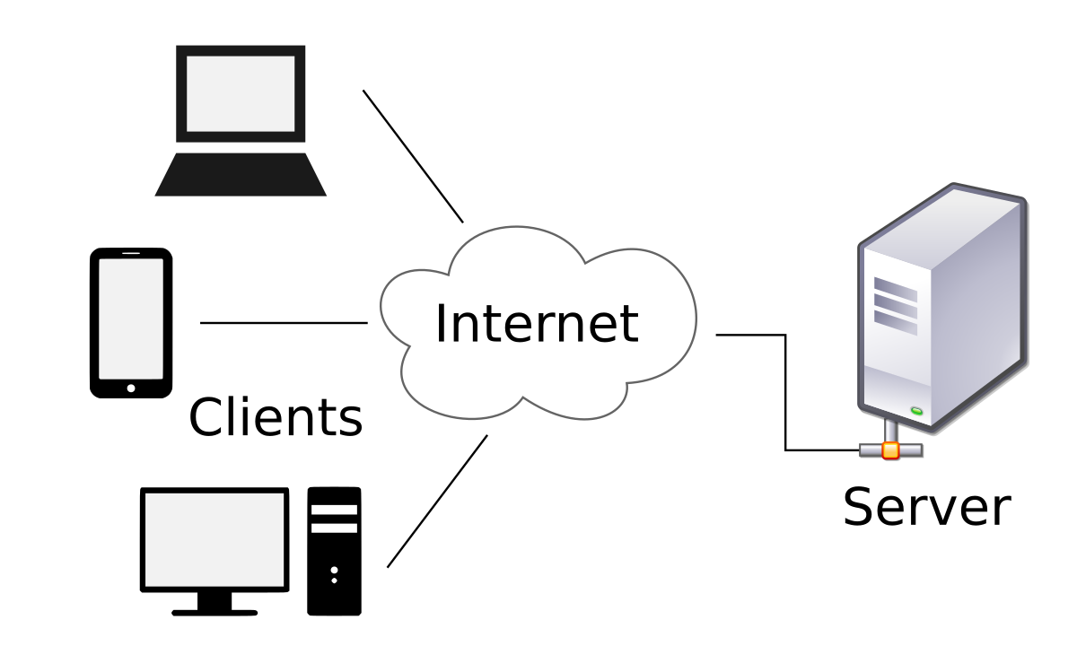

3 Architecture Design Pattern (15pts)

- What do we mean by “a big ball of mud” regarding software architecture? How could we avoid a system from becoming “a big ball of mud”? (5pts)

  - The Big Ball of Mud is an architectural anti-pattern. It refers to an architecture that lacks any modular design, and thus becomes just a mass of disorganized code lacking any real structure.
  - The best way to avoid having a system turn into a Big Ball of Mud is to put thought and effort into its design once it reaches a certain size. It's fine to build a proof-of-concept or demo with no concern for well-known principles and practices of software development.

- Use a diagram and example to explain 3-tier architecture pattern, what are the advantages and disadvantages of this architecture pattern? You need to list at least three different points of advantages and two different points of disadvantages. (10pts)
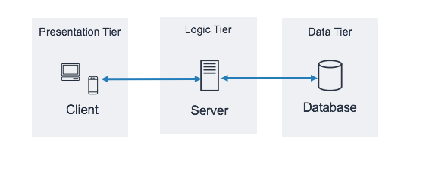
  - Client tier: how the application was shown to the user, aka front end, possibly written in HTML, CSS for websites, Swift for iOS application,…
  - Logic tier: consist of all logic related to the application, in short: which information should or shouldn’t be shown when, where and to whom
  - Data tier: basically the database, most famous being SQL (SQLite, mySQL,…), NoSQL (mongoDB,…)

  - Advantages:
    - Very easy to get started
    - Each tier can be scaled independently
    - Improve data integrity, since data has to pass through logic tier before being shown to the user, or before getting stored in the database
    - Great security since the user does not have direct access to the database → harder to obtain unauthorized data
  - Disadvantages:
    - High installation cost (need server allocation, good expertise in object oriented concept,…)
    - At some point, the system can be very difficult to maintain since it’s more difficult than 1&2 tier architectures
    - Performance will be affected given a large enough query

4. Identify suitable design patterns (5pts)

For each of the design purpose, provide the name of a suitable design pattern. (5pts)

- Arrange for a set of objects to be affected by a single object

- Provide an interface to a package of classes

- Create individual objects in situations where the constructor alone is inadequate

- Add responsibilities to an object at runtime

- Manage a large number of objects without construction them all

5. Command design pattern (20pts)

- Study the entry in Wikipedia for the “Command pattern” (https://en.wikipedia.org/wiki/Command_pattern ). Review the following piece of code. Explain why this represents an anti-pattern:), What are the disadvantages of the template suggested by the anti-pattern above?(5pt)

if (op==1)
{
User u = new User( request.getAttribute("user"), request.getAttribute("pass"));
}
else if (op==2)
{ ... }
...
The above piece of code represents an anti-pattern because:
  - It used “God-object”, which is the User class, that reference a large number of distinct types. User can be a guest, a normal user or even an admin, so User should be categorized to prevent unauthorized actions.
  - (possible) It only handle situation where op== 1 or 2, any other cases are assumed to never happen, if ignored they might cause the entire structure to collapse
The disadvantages:
  - Cannot differentiate between a normal user and any other types of user.

- Examine the code below that defines an abstract class. What part of the Command pattern does this achieve? What does the constructor achieve? (5pt)

//Action.java
public abstract class Action
{
protected Model model;
public Action(Model model)
{
this.model = model;
}
public abstract String getName();
public abstract Object perform(HttpServletRequest req);
}

The above code achieve the interface in command pattern
The constructor initialize the Action class, set the Model parameter in Action(Model) equal to the passed in model

- Examine the code below that defines a concrete class. What part of the Command pattern, does this achieve? Explain the method getName().(5pt)

// CreateUserAction.java:
public class CreateUserAction extends Action
{
public CreateUserAction(Model model)
{
super(model);
}
public String getName()
{
return "createUser";
}
public Object perform(HttpServletRequest req)
{
return model.createUser(req.getAttribute("user"),req.getAttribute("pass"));
}
}
The above code achieve the command class in command pattern
Method getName() should return a String of user name

- Examine the code below that defines a concrete class. What part of the Command pattern does this achieve? If this code is part of MVC, which part does it belong to? (5pts)
public class ControllerServlet extends HttpServlet {
private HashMap actions;
public void init(Model model) throws ServletException {
actions = new HashMap();
CreateUserAction que = new CreateUserAction(model);
actions.put(que.getName(), que);
//... create and add more actions
}
...
}

The above code achieve the action class, which should belongs to the model in MVC

6. Abstract factory pattern (20pts)

Study the code below of an abstract factory pattern,

- draw a class diagram that contains all the classes and methods (you may ignore multiplicity in the diagram)(10pts).

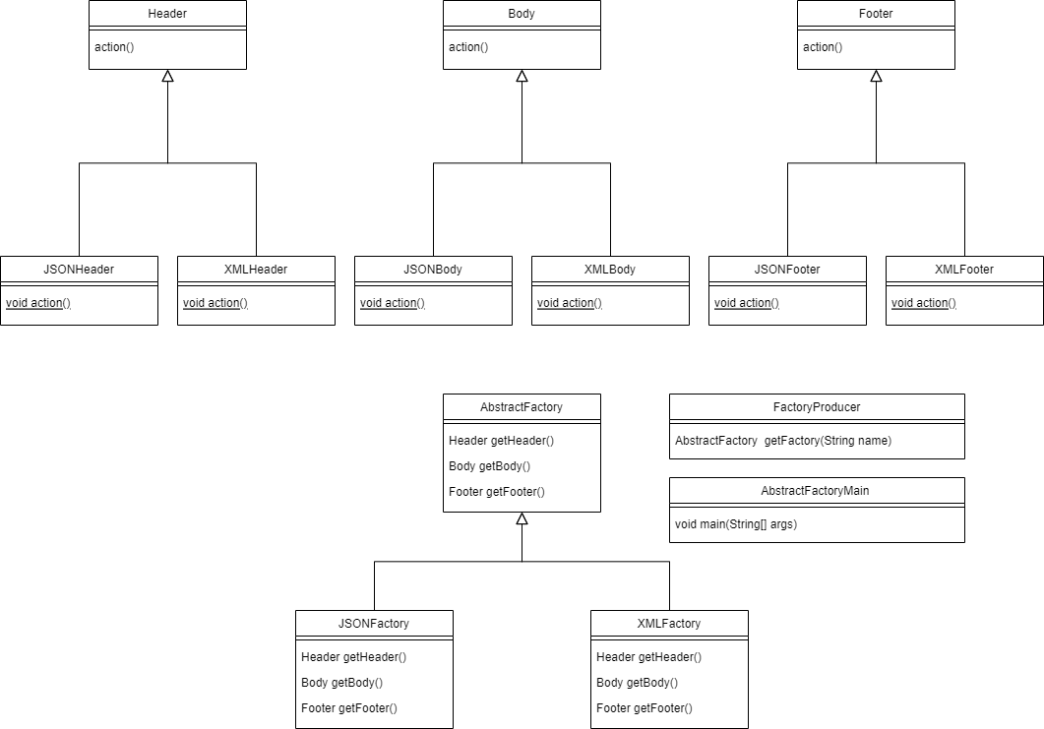
Class diagram

- Draw a sequence diagram to show scenario (10pts).

interface Header {
void action();
}

interface Body {
void action();
}

interface Footer {
void action();
}

class JSONHeader implements Header {
public void action() {
System.out.println("JSONHeader");
}
}

class JSONBody implements Body {
public void action() {
System.out.println("JSONBody");
}
}

class JSONFooter implements Footer {
public void action() {
System.out.println("JSONFooter");
}
}

class XMLHeader implements Header {
public void action() {
System.out.println("XMLHeader");
}
}

class XMLBody implements Body {
public void action() {
System.out.println("XMLBody");
}
}

class XMLFooter implements Footer {
public void action() {
System.out.println("XMLFooter");
}
}

abstract class AbstractFactory {
abstract Header getHeader();
abstract Body getBody();
abstract Footer getFooter();
}

class JSONFactory extends AbstractFactory{
Header getHeader() {
return new JSONHeader();
}

Body getBody() {
return new JSONBody();
}

Footer getFooter() {
return new JSONFooter();
}
}

class XMLFactory extends AbstractFactory {
Header getHeader() {
return new XMLHeader();
}
Body getBody() {
return new XMLBody();
}
Footer getFooter() {
return new XMLFooter();
}
}

class FactoryProducer {
AbstractFactory getFactory(String name) {
switch (name) {
case "XML": return new XMLFactory();
case "JSON": return new JSONFactory();
}
return null;
}
}

public class AbstractFactoryMain {
public static {
FactoryProducer factoryProducer = new FactoryProducer();
AbstractFactory abstractFactory = factoryProducer.getFactory("XML");
Header header = abstractFactory.getHeader();
header.action();
}
}

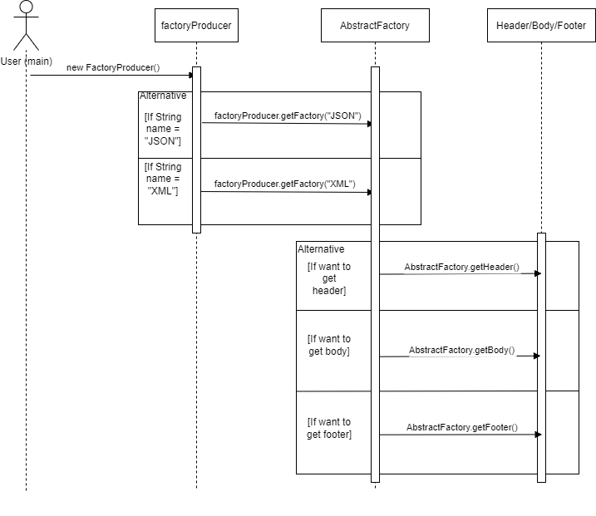

7. Interview (10pts)

The workshop teacher (assessor) will arrange a one-to-one interview at week 10 or 11 workshop time. During the interview, the assessor may ask you to explain your answers and discuss the marking. The interview will also cover your work in the assignments. The purposes of the interview are:
- Help you to clarify marking issues.
- Check your understanding.
- Check if the submitted work was done by you and other possible academic integrity issues.
If the assessor suspects that some of the submitted work was not completed by you, it might raise a concern and might deduct your marks accordingly.

8. Additional exercises for 3815ICT and 7805ICT

This question is not assessed, however, if you don’t complete this question, your other questions will not be marked (the question is only for students who enrol in 3815ICT and 7805ICT).

Knowledge regarding design pattern gave me a deeper understanding of how I normally write my code, even though it doesn’t help much in terms of determining how I wrote my code for the assignment (Tetris) since I’ve already finished the coding, it still give me a fresh view on the system on how it should be, how it could have been,…
Maybe in the future on another project, I might utilize other design pattern on other systems.

9. Additional exercises for 7805ICT

This question is not assessed, however, if you don’t complete this question, your other questions will not be marked (the question is only for students who enrol in 7805ICT).

Design an open-ended question (that means there may be several correct answers) that could be suitable for

- A final exam
Name some design pattern in software architecture
- A job interview for software engineer.
“Our current retail system use abstract factory pattern, if you were to redesign the entire system, which pattern would you use and why?”

